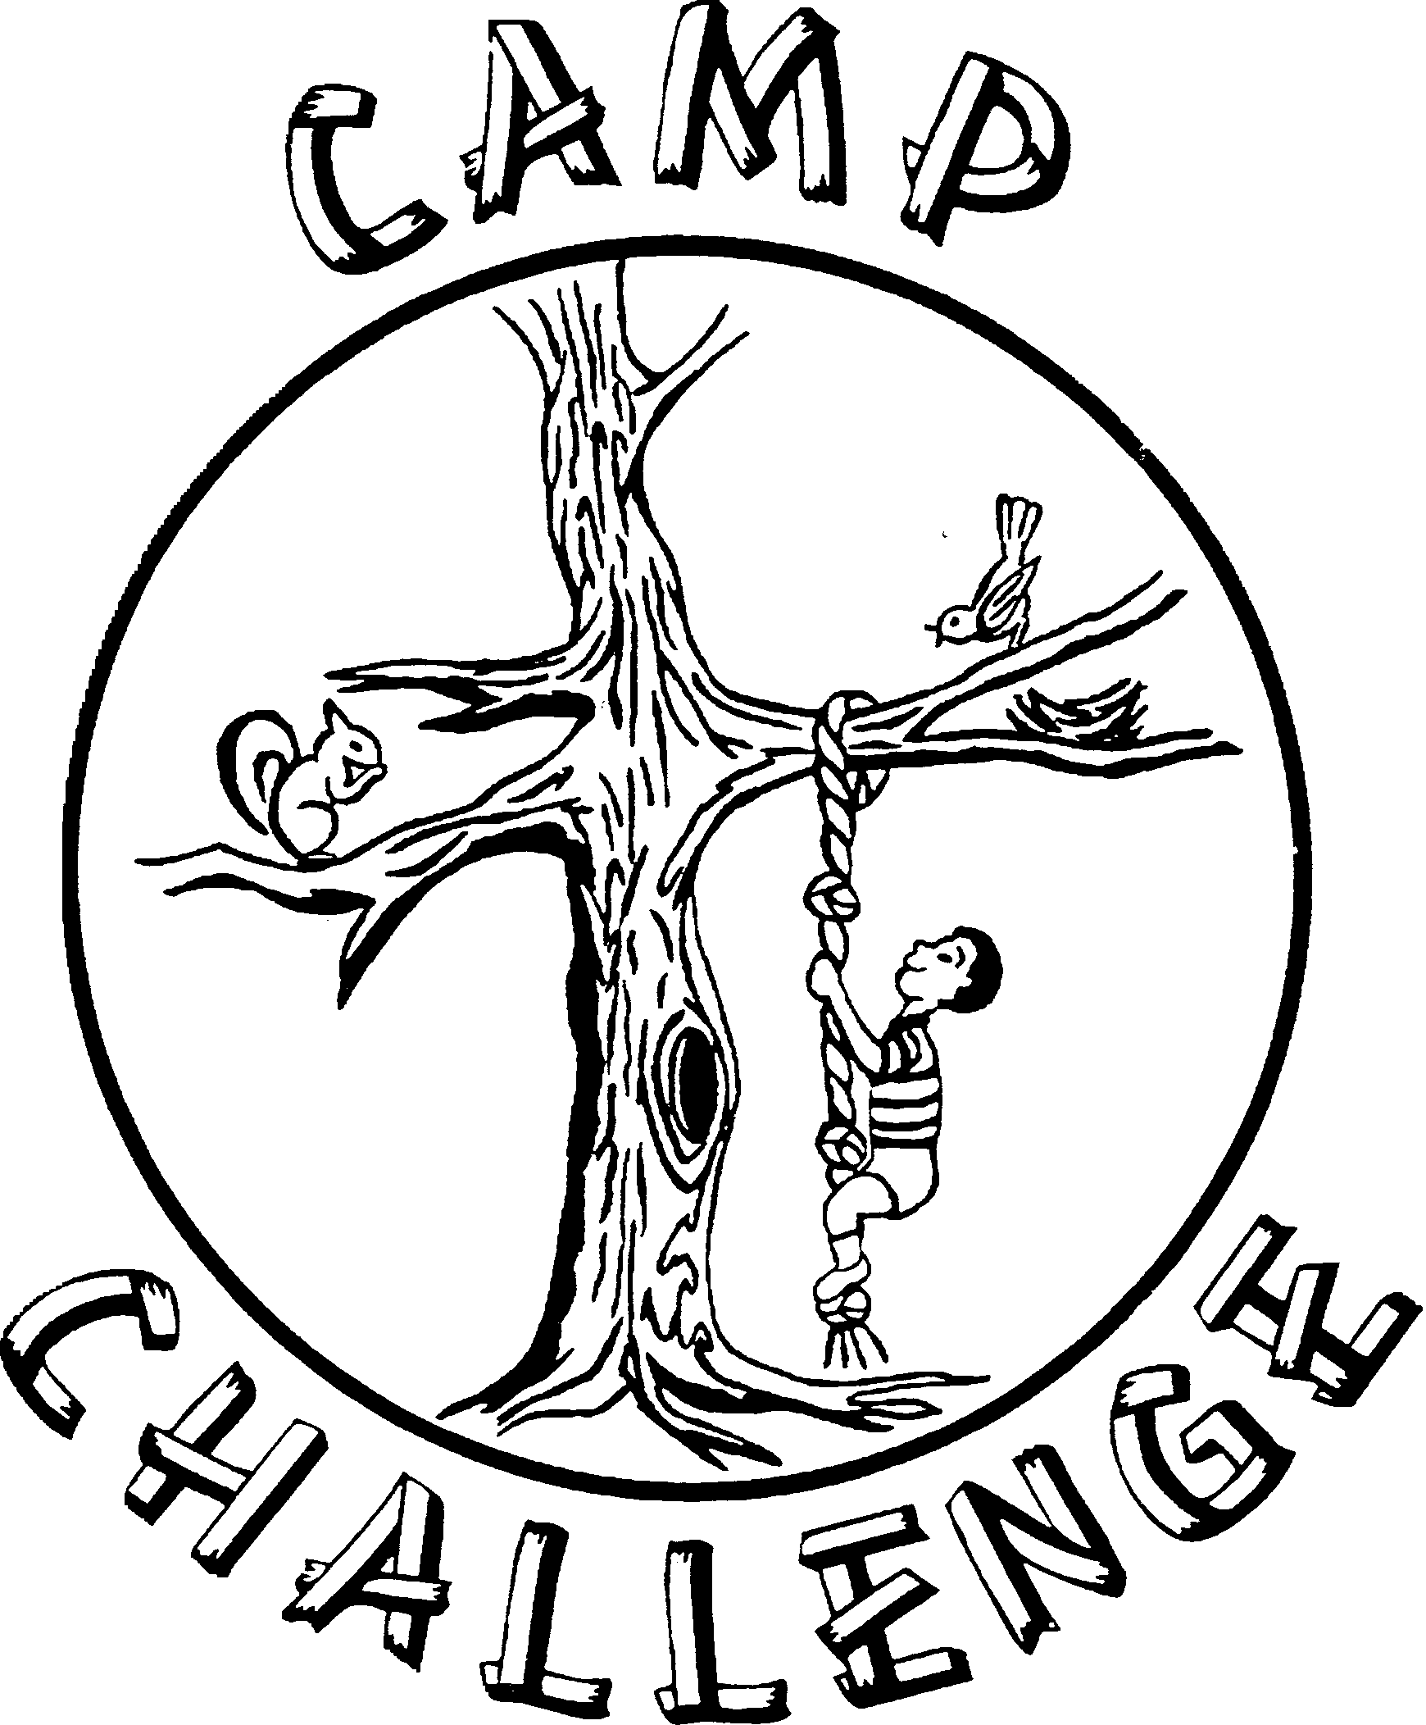
Camp Challenge
P.O. Box 10591
New Orleans, LA 70181
504-347-2267

Dear Parents:

It is my great honor to invite your child to join us for an exciting week of fun and excitement. This invitation entitles your child to endless memories, exciting events, and many friendships. Your child will experience a world of adventure at the 2016 session of CAMP CHALLENGE. If your child has been to CAMP CHALLENGE in the past, you know the value of camp memories. If Camp Challenge 2016 will be your child's first time at camp, you should be eager to give your child the chance to experience independence and to learn more about him/herself.

CAMP CHALLENGE is an Accredited Camp of the American Camping Association. To become accredited, we must comply with over 100 national camping standards. Each summer, we must prove that we are in compliance with ACA standards to maintain our status of accreditation. The purpose of this is to allow you, the parent, to know that we as a camp program and an organization have worked to meet all national guidelines for camping and that we will provide the best camp session possible to your child.

APPLICATIONS ARE NOW ONLINE……Please fill out the application completely and carefully. All of the information is necessary to process the application. Also, please pass this information on to any friends or family members that may have campers that qualify for camp.

Sincerely yours,
Cathy Allain
Cathy Allain(Treble),
Camp Director

***Applications WILL NOT be processed and will be returned to you if all of the information is not complete. PHYSICAL FORMS AND Copy of insurance cards and immunizations are part of the application and MUST BE RECEIVED before applications can be processed!***

www.campchallenge.org

CAMP CHALLENGE 2016

Camp Challenge is a one week overnight summer camp program for children with cancer and their siblings. The camping program is accredited by the American Camping Association.

CAMP DATES: Sunday, July 24, 2016 through Saturday, July 30, 2016

APPLICATION DEADLINE:
All applications are due June 20, 2016. They will be accepted after that date, but campers are accepted on a first come first serve basis. The number of staff we hire is based on the number of campers that have applied. We would also like to make sure we have enough supplies and a t-shirt for your child-so please get it in as soon as possible.

LOCATION: The camp will be held at the Louisiana Lions Camp in Leesville, Louisiana. It is an accredited site of the American Camping Association.

ELIGIBILITY: Any child (ages 5-15) with cancer or a hematological disease or their siblings. Camper eligibility is determined by the Board of Camp Challenge and is based on diagnosis, current condition and medical information provided on the application. Camp Challenge reserves the right to accept or refuse any camper based on information provided or past camp experience.

COST: Through the kindness of our many contributors, there is no cost or fee for camp. Campers should not bring money to camp.

MEDICAL CARE: Medical and therapeutic care is provided 24 hours a day by highly skilled professionals including physicians, nurses, and others.

STAFF: The camp program is staffed by volunteers. Each is screened for qualifications and standards set by the American Camping Association and the Board of Camp Challenge. All are highly motivated and dedicated to the service of children. Staff to camper ratio is approximately 1:1.5.

ACTIVITIES: Arts and crafts, swimming, field sports, campfires, hiking, nature, a talent show and much, much more! A rest period is provided each day after the noon meal.

INSURANCE: Campers are automatically covered by group medical insurance during the camp session. Parents and/or their own family health insurance are responsible for all medical bills not covered by the camp group insurance. PLEASE send A COPY OF YOUR CHILD’S INSURANCE CARD with THE APPLICATION. Applications will not be processed without them. You can scan them and email them to campdirector@campchallenge.org or fax them to 1-866-295-3803

MEDICATIONS: If your child is accepted as a camper you will receive a health form and instructions prior to coming to camp. All medication must be checked in with the medical staff. It must be clearly labeled, and you must send enough for the entire week. You must include prescription bottles.

KEEP THIS INFORMATION,YOU MAY NEED IT!

TRANSPORTATION: PLEASE READ THE FOLLOWING INFORMATION CAREFULLY AND CHECK THE APPROPRIATE BOX ON THE APPLICATION.

TYPES OF TRANSPORTATION

OWN: Parents will be responsible for providing transportation to and from the campsite in Leesville, Louisiana. No assistance will be necessary.

BUS: NEW ORLEANS and BATON ROUGE AREA CAMPERS
Campers may ride the bus provided by Camp Challenge to and from camp. Parents will be responsible for transporting campers to and from the bus at Children’s Hospital or their designated bus stop. ****There will be a new Baton Rouge Location-information in the next mailing!

APPLICATION INSTRUCTIONS: Please complete the application in ink. All questions must be answered and all parts must be completed.

CAMPER ACCEPTANCE: Once we have processed the application and determined that your child is eligible to attend camp, we will send you an acceptance package. Packages should be mailed in early June. This will include the rest of the information you will need as well as a confirmation card, which must be returned immediately. Please pay attention to deadlines and keep this information sheet for your reference.

If you have any questions or concerns, please call:

CATHY ALLAIN(TREBLE), Camp Director at(504) 347-CAMP
LEAVE A MESSAGE ON THE CAMP CHALLENGE VOICE MAIL
or E-Mail Cathy at campdirector@campchallenge.org

PLEASE COMPLETE THE ONLINE APPLICATION AND MAIL PHYSICAL FORM AND INSURANCE AND IMMUNIZATIONS to:
Camp Challenge
P.O. Box 10591
New Orleans, LA 70181
504-347-2267

CHECK THE WEBSITE FOR INFO AND UPDATES!
WWW.CAMPCHALLENGE.ORG

